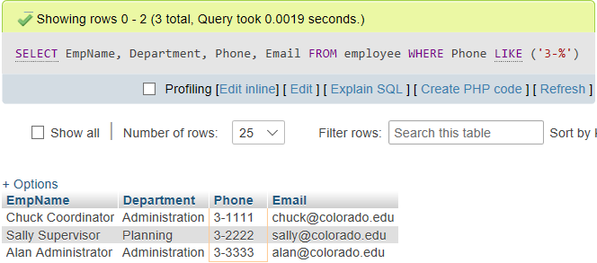

SELECT

empName,

department,

phone,

email

FROM Employee

WHERE phone LIKE ('3-%');